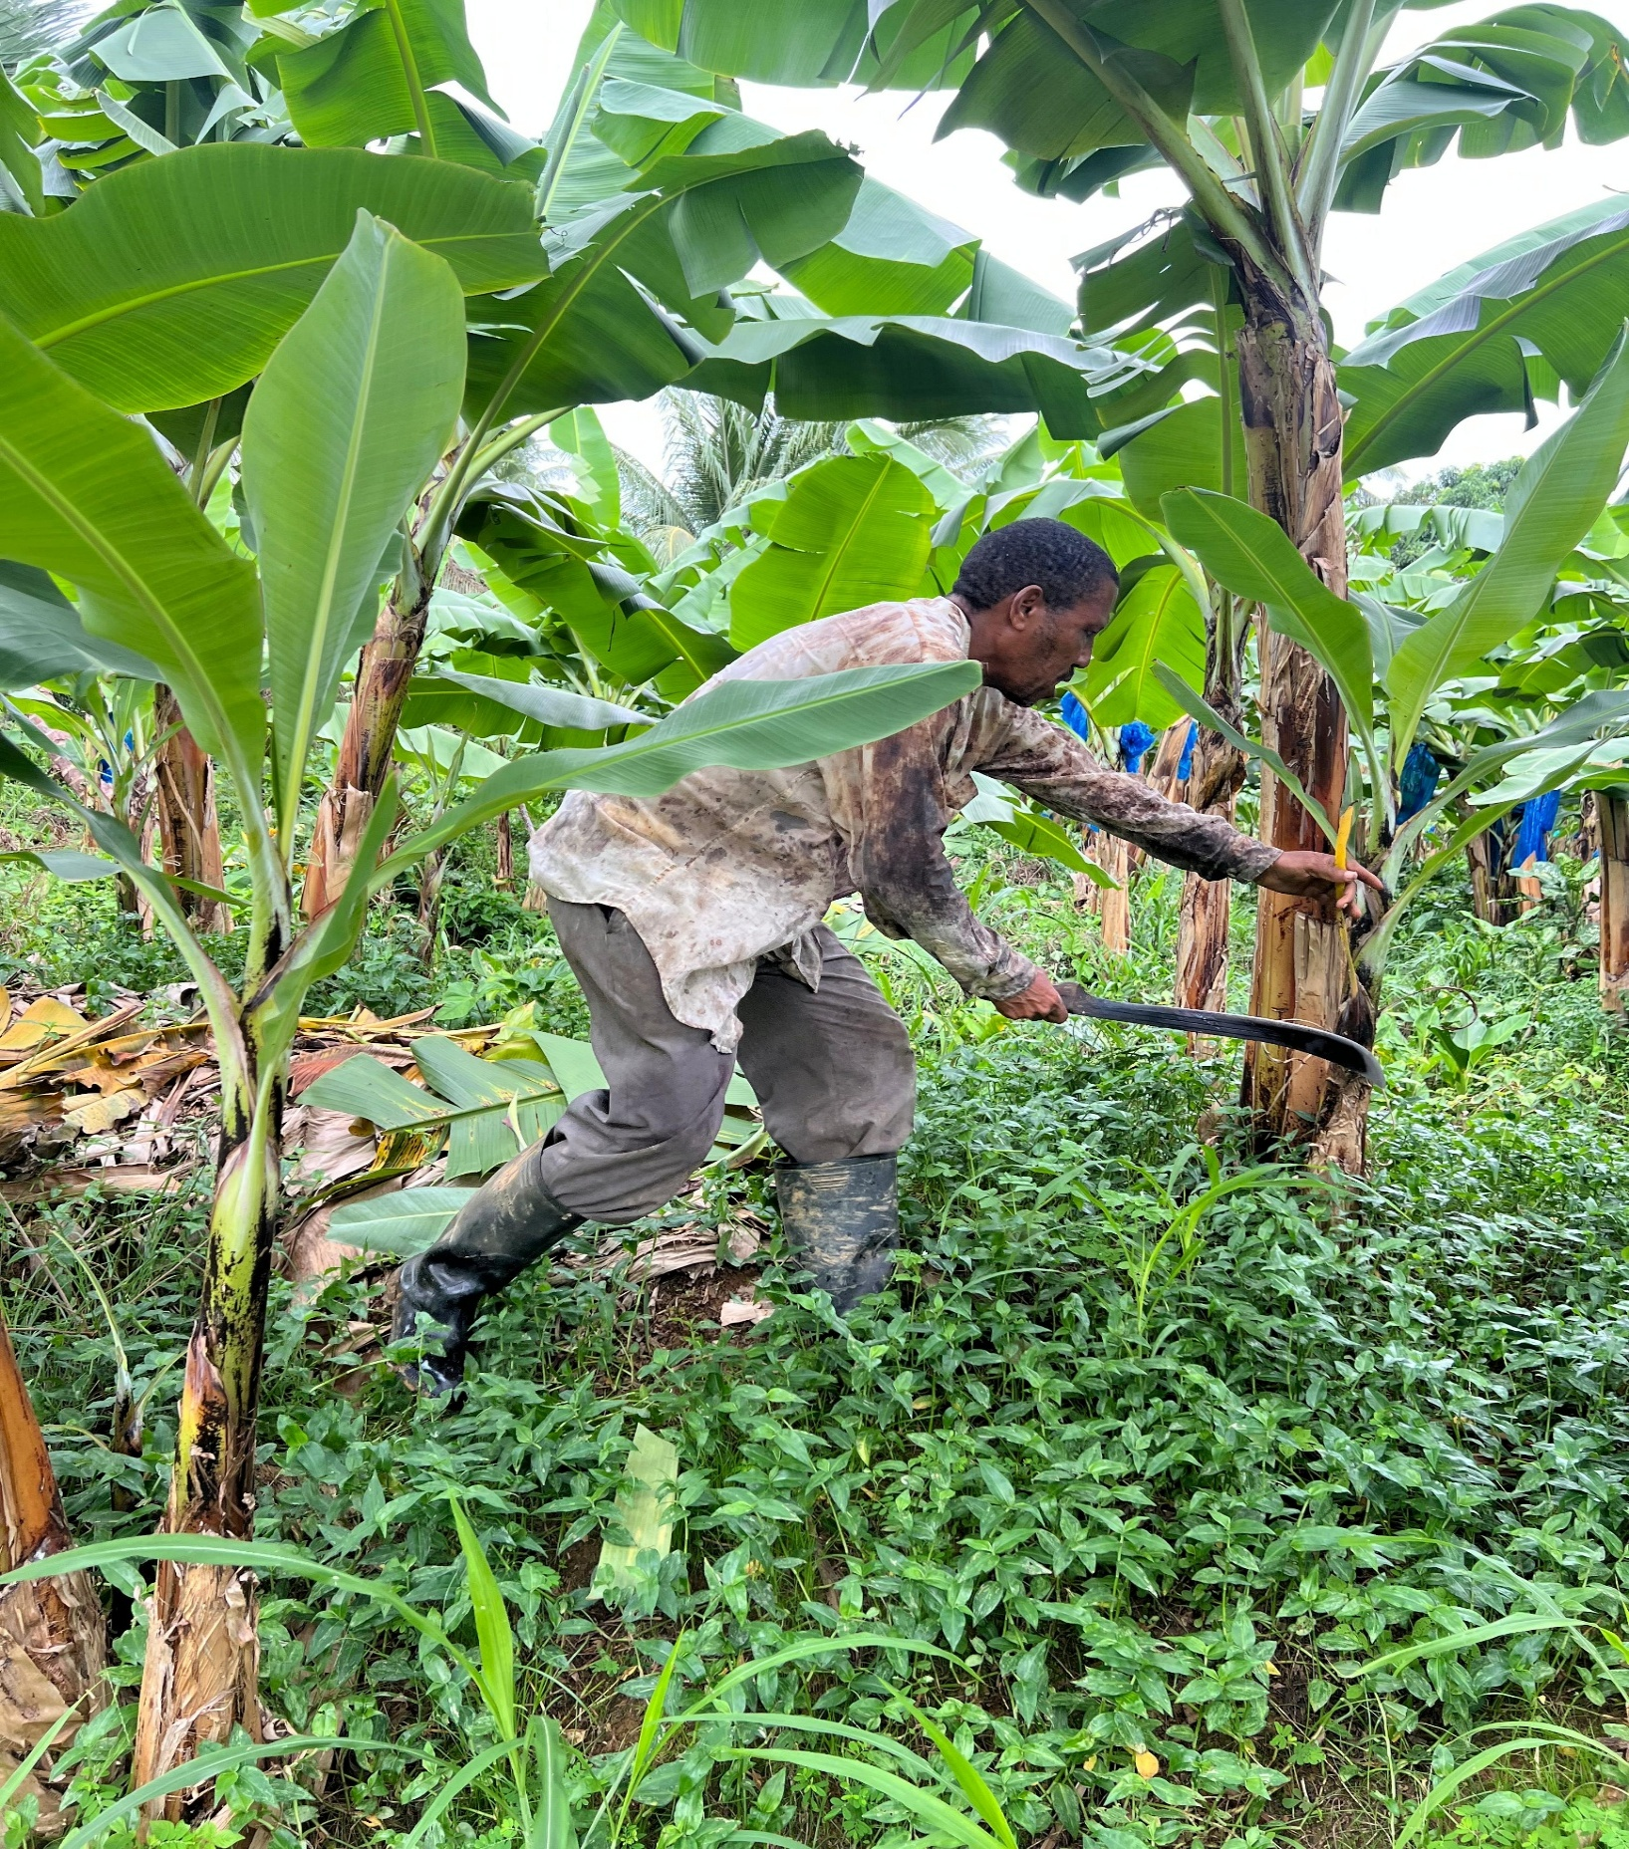

**Saint Lucia 2025**

**Labour Force Survey Snapshot**

***Website: https://stats.gov.lc/***

**Statistical Snapshot**

**1st Quarter 2025**

***Saint Lucia Central Statistical Office Website: https://stats.gov.lc/***

**Cautionary Note: Q1 2025 Labour Force Report**

***In accordance with our commitment to providing accurate and comprehensive statistical information, the Central Statistical Office (CSO) wishes to inform all stakeholders, including the general public and data users, about the scope of the forthcoming Labour Force Report for the ~~fourth~~ first quarter of 2025 (Q1 2025), January to March 2025.***

***Information contained in this report is the result of a Household Labour Force Survey, ~~conducted during the first quarter of 2025,~~ ~~from January to March 2025~~ and is aimed at providing information about the level of participation of household members in the labour force and the size of the labour force, aged 15 years and above, engaged in economic activities.***

***It must be noted that the Central Statistical Office (CSO) always strives to ensure that our procedures and processes for the implementation of the Labour Force Survey are in keeping with proven methodologies and international standards. Therefore, the results represent the collated responses of a sample of households interviewed during the period in question and not the opinion of the Central Statistical Office. Results from sample surveys are always estimates, not precise figures.***

***We appreciate your understanding and patience as we diligently compile accurate and comprehensive labour market statistics. To assure the reliability and international alignment of our data, we collaborate closely with the International Labour Organization (ILO). The CSO remains committed to transparency and quality in our data reporting practices.***

**Contents**

**Key Labour Market Indicators and Formulas** 3

**EMPLOYED LABOUR FORCE** 6

**UNEMPLOYED LABOUR FORCE** 11

**Statistical Output** 12

# **Key Labour Market Indicators and Formulas**

***The following are the international standard definitions of the main concepts underlying the unemployment rate, as stated in the Resolution concerning statistics of work, employment and labour underutilization adopted by the 19th International Conference of Labour Statisticians in 2013.***

1. ***Labour force:*** *The current supply of labour for the production of goods and services in exchange for pay or profit, computed as the sum of persons in employment and in unemployment.*

***Labour Force = Employed Labour Force + Unemployed***

1. ***Labour Force Participation Rate:****is the percentage of a country's working-age population that is either employed or actively looking for work:*

***Labour Force Participation Rate = Labour Force X 100 / Population 15 years and over***

1. ***Employment:*** *A person in employment as defined by the International Labour Office (ILO) is a person aged 15 or over who has done at least one hour's paid work in a given week, or who is absent from work for certain reasons (annual leave, sickness, maternity, etc.) and for a certain period of time. All forms of employment are covered (employees, self-employed, family helpers), whether the employment is declared or not.*

*The unemployment rate is computed as follows:*

***Employment rate: The percentage of the working-age population that is employed:***

***Employment rate=Number of employed individuals/Total labour force (times 100)***

1. ***Unemployment:*** According to the International Labour Organization (ILO), unemployment is defined as a person who meets the following criteria**:**

* ***Is at least 15 years old***
* ***Is not employed during a given week***
* ***Is available to work within two weeks***
* ***Has actively sought work in the last four weeks or has found a job that starts within three months***

Therefore, persons in unemployment are define as *all those of working age who were not in employment, carried out activities to seek employment during a specified recent period and were currently available to take up employment given a job opportunity.*

*Based on this, the unemployment rate is computed as follows:*

* ***Unemployment Rate = Unemployed X 100 / Labour Force***
* ***Male Unemployment Rate = (No. of Unemployed Males / Total No. of Males in the Labour Force) X100***
* ***Female Unemployment Rate = (No. of Unemployed Females/ Total No. of Females in the Labour Force) X100***
* ***Youth Unemployment: For the purpose of this indicator, the term "youth" covers persons aged 15 years to 29 years.***

***Youth Unemployment Rate = Unemployed Youths as a percentage of the Youth Labour Force***

The statistical output of the third quarter Labour Force Survey highlights short-term trends, provides a comparison within quarters, the immediate changes (Year to Year), and the most recent movement within the labour market, 4th quarter 2024 to 1st quarter 2025. It's useful for understanding what happened very recently and if there's an upward, downward, or stagnant trend. This comparison helps to highlight seasonal effects and provides a clearer picture of the long-term or underlying trend in the data. It indicates whether the current performance is better, worse, or similar to the same period in the past.

***Table 1: Labour Force Rates of the Working Age Population by Age***

|  |  |  |  |
| --- | --- | --- | --- |
| **Age Group** | **Labour Force Participation Rate** | **Unemployment Rate** | **Employment Rate** |
| **15-19 Years** | **26.4** | **71.8** | **28.2** |
| **20-24 Years** | **82.9** | **18** | **82** |
| **25-29 Years** | **98.4** | **14.2** | **85.8** |
| **30-34 Years** | **91.6** | **16.9** | **83.1** |
| **35-39 Years** | **93.7** | **9.2** | **90.8** |
| **40-44 Years** | **96.8** | **7.6** | **92.4** |
| **45-49 Years** | **96.9** | **12.7** | **87.3** |
| **50-54 Years** | **94.2** | **11.5** | **88.5** |
| **55-59 Years** | **82.2** | **8** | **92** |
| **60-64 Years** | **75.4** | **12.3** | **87.7** |
| **Over 65 Years** | **21.3** | **22.1** | **77.9** |
| **Total** | **71.4** | **14.1** | **85.9** |

While the total labour force increased from Q1 2024 to Q1 2025, and also from Q4 2024 to Q1 2025, the growth in employment has been much slower or less in the most recent period. This suggests that more people are entering the labour force, but not enough jobs are being created to absorb them, leading to higher unemployment. The data revealed a trend of more females entering the labour force, and an increasing number of unemployed females. In contrast, the male labour force has seen a decrease (see table 2 below).

While the total labour force continued to grow, expanding by 3.85% compared to Q1 2024 and 3.62% since Q4 2024, the rate of job creation has lagged significantly. This is reflected in the total employment, which saw a modest 0.62% increase year-over-year. Notably, it decreased by 2.43% from the previous quarter (Q4 2024 to Q1 2025), leading to higher unemployment figures.

The data revealed a significant shift in gender dynamics, with women increasingly entering the workforce (see Table 2). The female labour force grew by over 16% both year-over-year and quarter-over-quarter, while the male labour force simultaneously contracted by more than 6% in both comparisons. However, this increased female participation has not been met with sufficient employment opportunities, as evidenced by a striking 72.93% rise in unemployed females since Q1 2024, and an even more dramatic 113.84% increase from Q4 2024. Consequently, the overall unemployment rate climbed by 2.7 percentage points year-over-year to 14.1%, and 5.3 percentage point increase from the last quarter, signalling a notable decline in the labour market conditions, particularly for women, in Q1 2025.

***Table 2: Main Indicator, Labour Force Survey***

|  |  |  |  |
| --- | --- | --- | --- |
| **Labour Force Indicators** | **1st Qtr. 2025** | **Unemployment Rate %** | **14.1%** |
|  |  | **of which - Male** | **9.0%** |
| **Estimated Household Population** | **185272** | **of which- Female** | **19.1%** |
| **Population 15 years and over** | **158482** |  |  |
| **Labour Force** | **112994** | **Youth Unemployment Rate %** | **0.0%** |
| **of which - Male** | **55443** |  |  |
| **of which- Female** | **57551** | **Relaxed Unemployment Rate %** | **15.3%** |
|  |  |  |  |
| **Employed Labour Force** | **97033** | **Non-Job Seeking Rate %** | **1.2%** |
| **of which -Male** | **50456** |  |  |
| **of which -Female** | **46578** | **Population under 15 years (%)** | **14.5%** |
| **Employment Rate** | **85.9%** | **Labour Force as a Percentage of Total** |  |
|  |  | **Population** | **61.0%** |
| **Persons who want work** |  |  |  |
| **(I) The Unemployed** | **15961** | **Labour Force as a Percentage of** |  |
| **of which - Male** | **4987** | **Population 15 years and over OR** |  |
| **of which- Female** | **10974** | **Labour Force Participation Rate** | **71.3%** |
| **(ii) Non-Seekers** | **1321** |

# **EMPLOYED LABOUR FORCE**

The provided table 3 and Figure 1," Employed Labour Force by Age Group and Sex," present a quarterly breakdown of employment figures by age group for Saint Lucia, covering the 1st Quarter of 2025, 4th Quarter of 2024, and 1st Quarter of 2024. The total employed labour force in Saint Lucia for the 1st Quarter of 2025 was 97,033, which represents a slight decrease from 99,453 in the 4th Quarter of 2024 but an increase from 96,434 in the 1st Quarter of 2024.

The age distribution for Q1 2025 showed, the largest age group in terms of employment was "45-49 Years" with 10,609 employed individuals, closely followed by "35-39 Years" with 10,591 and "50-54 Years" with 11,531. In contrast, the youngest demographic, "15-19 Years," consistently had the lowest employment figures, with 0.69% in Q1 2025, a significant drop from 1.11% in Q4 2024 and 1.36% in Q1 2024. The "Over 65 Years" group also showed a notable decrease in employment from 8.31% in Q4 2024 to 5.85% in Q1 2025, as depicted in Table 3.

Comparing the quarters, there are some shifts in employment concentration. The distribution of the workforce by age group reveals shifts between Q1 2024 and Q1 2025. While the 20-24, 25-29, and 45-49 age groups generally represented significant portions of the workforce, their percentages fluctuated, with the 25-29 group notably increasing its share in Q1 2025 after a peak in Q4 2024. Conversely, the 15-19 age ***group saw a consistent decline in its share. The 30-34 and 35-39 age***

***Figure 1: Employed Labour Force by Age Group and Sex Qtr. 1 2025***

groups experienced some shifts in their relative proportions, while the over 65 years group also saw a decrease in its share from Q4 2024 to Q1 2025, after an increase from Q1 2024. These changes suggest dynamic movements in the age composition of the workforce over the observed period. These fluctuations indicate changes in employment distribution across different age cohorts

|  |  |  |  |
| --- | --- | --- | --- |
| **Age Group** | **1 Qtr 2025 (%)** | **4th Qtr 2024 (%)** | **1st Qtr 2024 (%)** |
| 15-19 Years | 0.69 | 1.11 | 1.36 |
| 20-24 Years | 8.95 | 10.29 | 10.39 |
| 25-29 Years | 10.09 | 11.18 | 9.56 |
| 30-34 Years | 10.25 | 9.59 | 10.82 |
| 35-39 Years | 10.91 | 8.63 | 9.11 |
| 40-44 Years | 9.84 | 8.91 | 9.48 |
| 45-49 Years | 10.93 | 10.77 | 12.88 |
| 50-54 Years | 11.89 | 12.83 | 11.64 |
| 55-59 Years | 11.43 | 9.39 | 11.2 |
| 60-64 Years | 9.19 | 8.95 | 7.42 |
| Over 65 Years | 5.85 | 8.31 | 6.12 |
| **Total** | **100** | **100** | **100** |

within Saint Lucia’s labour force over the period under review.

***Table 3: Employed by age Group Over Quarters***

Table 4: Employed Labour Force by Occupation Group details the shifts occurring between various job categories over the observed quarters in Saint Lucia. The total employed labour force stood at 97,033 in Q1 2025, a slight decrease from 99,453 in Q4 2024 but an

increase from 96,434 in Q1 2024. In the 1st Quarter of 2025, Service and sales workers continued to be the largest occupational group, accounting for 30% of the employed population, an increase from the previous quarter, while their percentage slightly decreased from 30.28% in Q1 2024 to 29.93% in Q1 2025. Elementary occupations (such as cleaners, street vendors) also maintained a substantial portion of employment, fluctuating from 14.54% Q1 2024 to 14.19% in Q1 2025. Craft and related trades workers saw an increase from 10,487 in Q4 2024 to 11,250 in Q1 2025. 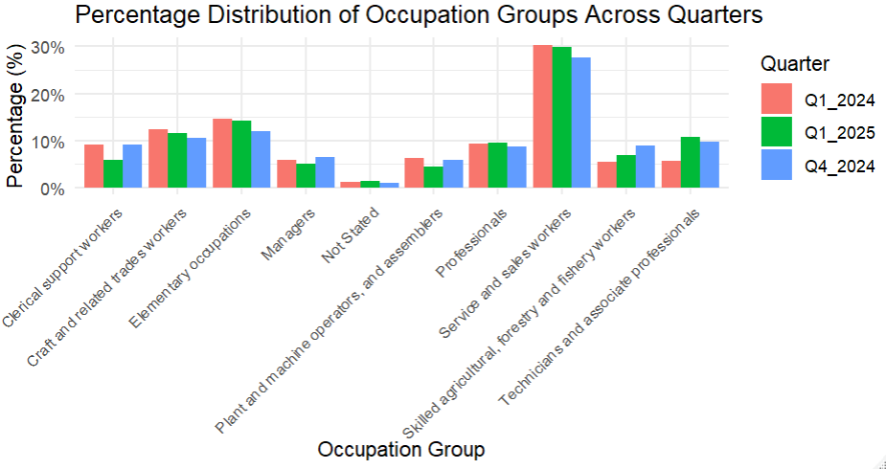Some notable shifts are apparent when comparing quarters. For instance, Managers saw a decrease in employment from 5.8% in Q4 2024 to 5.14% in Q1 2025. Skilled agricultural, forestry and fishery workers also decreased from 8,816 in Q4 2024 to 6,680 in Q1 2025. On the other hand, Technicians and associate professionals saw a significant proportional increase, rising from 5.59% to 10.73% over the year. Additionally, the same category saw an increase from 9.7% in Q4 2024 to 10.7% in Q1 2025, suggesting a potential shift toward more technical employment. Occupations like Clerical support workers and Plant and machine operators, and assemblers experienced noticeable decreases in their share of the total workforce, indicating a potential restructuring within these sectors.

***Figure 2: Percentage Distribution of Occupation across Quarters***

***Table 4: Occupation Group Over Quarters***

|  |  |  |  |
| --- | --- | --- | --- |
| **OCCUPATION GROUP** | **1st Qtr. 2024 (%)** | **4th Qtr. 2024 (%)** | **1 Qtr. 2025 (%)** |
| **Managers** | **5.8** | **6.56** | **5.14** |
| **Professionals** | **9.42** | **8.66** | **9.54** |
| **Technicians and associate professionals** | **5.59** | **9.7** | **10.73** |
| **Clerical support workers** | **9.11** | **9.08** | **5.92** |
| **Service and sales workers** | **30.28** | **27.62** | **29.93** |
| **Skilled agricultural, forestry and fishery workers** | **5.44** | **8.86** | **6.87** |
| **Craft and related trades workers** | **12.49** | **10.55** | **11.59** |
| **Plant and machine operators, and assemblers** | **6.21** | **5.93** | **4.51** |
| **Elementary occupations** | **14.54** | **11.96** | **14.19** |
| **Not Stated** | **1.13** | **1.1** | **1.38** |
| **Total** | **100** | **100** | **100** |

The Employed Labour Force by Industry Group, represented in Figure 3, provides a snapshot of employment across various sectors in Saint Lucia for the 1st Quarter of 2025, 4th Quarter of 2024, and 1st Quarter of 2024. Overall, the total employed labour force in Saint Lucia for the 1st Quarter of 2025 stood at 97,033 individuals. This marks a slight decrease from the 4th Quarter of 2024, which recorded 99,453 employed persons, and an increase from the 1st Quarter of 2024, which had 96,434 employed individuals. **Wholesale and retail trade**; **repair of motor vehicles and motorcycles** consistently remained the largest employer across all three quarters, with 14,050 employed in Q1 2025, 14,877 in Q4 2024, and 16,919 in Q1 2024. **Accommodation and food service activities** also showed significant employment figures, totalling 16,059 in Q1 2025, a notable increase from 14,222 in Q4 2024 and 15,517 in Q1 2024.

Comparing Q1 2025 to Q4 2024, some sectors experienced declines in employment, such as **Agriculture, forestry and fishing** (from 9,793 to 8,095) and **Manufacturing** (from 6,066 to 4,625). Conversely, **Construction** saw an increase, moving from 7,337 in Q4 2024 to 7,595 in Q1 2025. **Public administration and defence; compulsory social security** also experienced a slight decrease from 8053 to 7641.

***Figure 3: Employed by Industry Group Qtr. 1 2025***

# **UNEMPLOYED LABOUR FORCE**

The unemployment figures from the Labour Force Survey show an upward trend in the overall unemployment rates for the 1st quarter of 2025. Saint Lucia’s unemployment rate increased sharply to **14.1%**, a significant rise from **8.8%** in the previous quarter (Q4 2024) and even higher than the **11.4%** recorded in Q1 2024. This signals growing labour market challenges in the post-holiday (seasonality) or early-year period. Accommodation, Food, Services within the period were the only major sector to realize an increase from the previous period Qtr.4 2024.

***Figure 4: Unemployed Labour Force over Quarters by Sex.***

Analyzing the gender-specific rates for Q1 2025, the female unemployment rate stood significantly higher at 19.1% compared to the male unemployment rate of 9.0%. Both male and female unemployment rates increased from Q4 2024 (7.4% for males and 10.4% for females) and also from Q1 2024 (10.2% for males and 12.8% for females). A significant increase was revealed within the employed age cohort 20-24 Years. This indicates a substantial increase among the youth for the period in question.

**Youth unemployment** also saw a substantial rise in Q1 2025, reaching 21.4%. This is an increase from 16.3% in Q4 2024 and 18.4% in Q1 2024. The consistently higher youth unemployment rate underscores persistent challenges for younger individuals entering the job market. Table ....

A closer look reveals that female unemployment grew to 19.1%, more than double the male rate of 9.0%. This suggests that women were disproportionately affected by job losses or had greater difficulty re-entering the workforce, such as sectoral vulnerabilities where female employment is concentrated (e.g., clerical or retail roles).

# **Statistical Output**

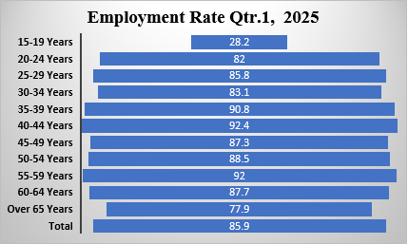 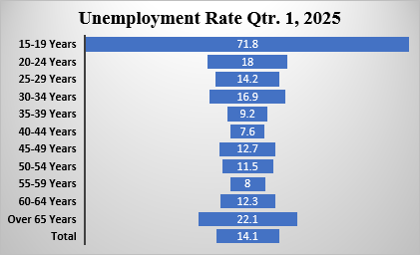

***Figure 5: Employment Rate Qtr.1 2025 Figure 6: Unemployment Rate Qtr. 1 2025***

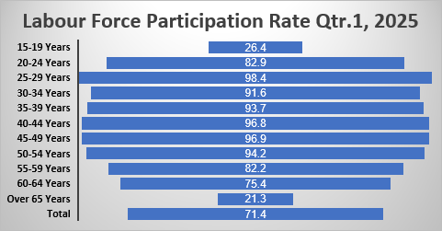

***Figure 7: Employment Rate Qtr. 1 2025***

***Figure 8: Labour Force Participation Rate (LFPR) and Unemployment Rate (UR) of the Working Age Population by Age in SAINT LUCIA.***

***Figure 9: Employed Labour Force by Occupation Group Over Quarter***

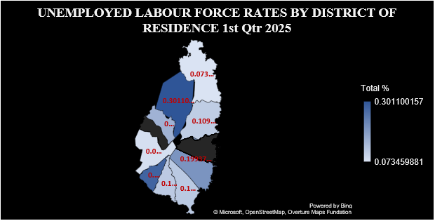

***Figure 10: Unemployed Labour Force Rates By District Of Residence 1st Qtr 2025***